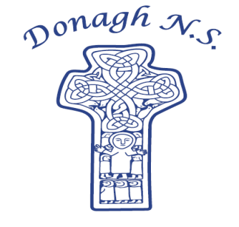Donagh National School

Carndonagh, Co. Donegal, F93 CX21

Tel: 074 93 74556

Email [office@donaghns.ie](mailto:office@donaghns.ie)

**Dates for your Diary – May & June**

**Mondays:** Pupils from 2nd-6th class will take part in tin whistle & traditional Irish music lessons with Múinteoir Róisín. €2 per pupil, per week.

**Tuesdays:** All students will participate in a Jujutsu workshop for four weeks commencing 13th May.

**Friday:** 1st – 6th class pupils will attend swimming lessons in Templemore Sports Complex from Friday 2nd May, for a period of 6 weeks.

### June: Súgradh le Chéile workshop for our new entrants, Junior infants and Senior infants – awaiting confirmation of a date from the Donegal Sports Partnership.

All pupils will attend the Wildwoods Beach & Forest School, Culdaff - awaiting confirmation of dates.

**Thursday, 1st May:** CCS representatives will visit Donagh N.S. to meet 6th class.

**Friday, 2nd May:** Assembly led by Claire from C.E.F.

### Monday, 5th May: School closed for Bank holiday.

**Tuesday, 6th May:** Chess tournament and training workshop at 1pm for senior pupils and their parent/grandparent.

**Monday, 12th May -** Food Dudes Week – See attached letter.

**Friday, 16th May**

**Friday, 23rd May:** Assembly led by Claire from C.E.F.

**Monday, 2nd June:**  School closed for Bank holiday.

**Thursday, 12th June:** Induction morning for new September 2025 entrants.

**Friday, 13th June:**  Sports Day at Glentogher School. Everyone welcome.

***P.T.O.***

**Monday, 16th June:** Junior Infants-2nd class will visit Alcorns Tropical World and Century Complex for their summer school tour.

**Wednesday, 18th June:** 3rd class-6th class will visit ATU Letterkenny for their summer school tour.

**Friday, 20th June:** End of Year Service and Celebration at 10.00a.m.in Donagh Church. Everyone welcome.