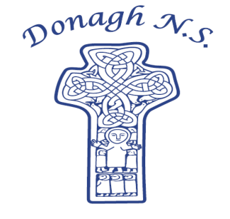Donagh National School

Carndonagh, Co. Donegal, F93 CX21

Tel: 074 93 74556

Email [office@donaghns.ie](mailto:office@donaghns.ie)

**Dates for your Diary – November & December**

**Mondays:** Pupils from 2nd-6th class will take part in tin whistle & traditional Irish music lessons with Múinteoir Róisín.

Co-operative games with John Gibbons for Junior pupils**.**

**Tuesdays:** All pupils will take part in a Drama workshop with Emma Porter of Vivid Performances.

**Fridays:** 2nd-6th class will continue take part in an Irish Sign Language lesson for a period of 3 weeks in November.

All classes will attend assembly led by Rev.Poots fortnightly.

**Thursday, 9th November:** Parent Teacher Meetings.

**Tuesday, 14th November:** Heritage in Schools Day with Johnny Shiels – Senior pupils will be making a nativity set for the school using wood burning tools.

**Wednesday, 15th November:** Senior pupils will participate in a virtual tour of the National Gallery as part of our Creative Schools activities.

**Tuesday, 22nd November:** Senior pupils will participate in an art making workshop online with an arts facilitator from the National Gallery as part of our Creative Schools activities.

**Friday, 8th December:** Christmas Jumper Day in aid of Crumlin Hospital.

**Tuesday, 12th December:** Heritage in Schools Day with Johnny Shiels – Senior pupils will complete the nativity set using wood burning tools.

**Thursday, 14th December:** Christmas Service in The Hillhead Presbyterian Church.

(More details to follow).

**Friday, 15th December:** Christmas Draw Raffle.

***P.T.O.***

**Monday, 18th December:** Senior pupils will visit Carndonagh library for a book quiz and craft making relating to their current class novel ‘The Lion, The Witch and The Wardrobe’.

**Wednesday, 20th December:** Trip to the Panto – Jack and The Beanstalk.

**Thursday, 21st December:** Exchange of Secret Santa gifts.

**Friday, 22nd December**: Half day school closure for Christmas Holidays at 12.30p.m. – School reopens Monday, 8th January 2024.

**Secret Santa**

The children will exchange their Secret Santa gifts on Thursday, 21st December. We request that all Secret Santa gifts are in school by Friday, 15th December. Class teachers will arrange Secret Santa details with their pupils over the coming week. Gifts should not cost any more than €7.

**Reverse Advent Calendar**

During the month of December the school will participate in a Reverse Advent Calendar. Each family will be asked to bring in an item of non-perishable food on their day which we will donate to the Inishowen Food Bank co-ordinated by Spraoi & Spórt. Class teachers will let children know when it is their turn to donate.