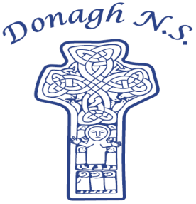
Donagh National School
Carndonagh, Co. Donegal, F93 CX21
Tel: 074 93 74556
Email office@donaghns.ie

Dates for your Diary – April-May

Mondays: Pupils from 2nd-6th class will take part in tin whistle & traditional Irish music lessons with Múinteoir Róisín.
Tuesdays: Hurling skills and co-operative games with Cathal Doherty for Senior pupils.
All pupils will take part in a Drama workshop with Emma Porter of Vivid Performances.
Wednesdays: All students will participate in a Jujutsu workshop.
Fridays: 1st – 6th class pupils will attend swimming lessons in Templemore Sports Complex from April 26th, for a period of 6 weeks.

Friday, 12th April: Woodwork workshop with Jonny Shiels.
Wednesday, 17th April: Assembly led by Claire from C.E.F.
Friday, 19th April: Woodwork workshop with Jonny Shiels.
Monday, 22nd April: Junior Classroom will enjoy a visit from some local Gardaí.
Wednesday, 8th May: Assembly led by Claire from C.E.F.
Thursday, 9th May: Heritage in Schools – Nature/Outdoor activities with Aengus Kennedy.

Friday, 24th May: Súgradh le Chéile for our new entrants, Junior infants and Senior infants.
Wednesday, 29th May: Assembly led by Claire from C.E.F.

