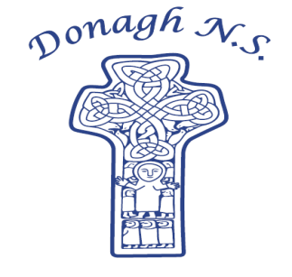Donagh National School

Carndonagh, Co. Donegal, F93 CX21

Tel: 074 93 74556

Email [office@donaghns.ie](mailto:office@donaghns.ie)

**Dates for your Diary – March & April**

**Mondays:** Pupils from 2nd-6th class will take part in tin whistle & traditional Irish music lessons with Múinteoir Róisín. €2 per pupil, per week.

**Tuesdays:** Hurling skills and co-operative games with Cathal Doherty for junior pupils.

Drama with Emma Porter for all classes.

**Thursdays:** Music with Siobhan Shiels for senior classes – links to wellbeing, a sense of place and our local heritage.

**Friday:** Hurling skills and co-operative games with Cathal Doherty for senior pupils.

Chess club for Senior pupils.

**March:** Senior pupils will take part in Spanish lessons with Nora McQuaid.

**Wednesday, 5th March:** 3rd-6th class pupils will participate in the Marine Explorers Education programme with William McElhinney.

**Thursday, 6th March:** World Book Day. All pupils will visit Carndonagh Library. Witches and Wizards/Harry Potter theme.

**Monday, 10th Márta -** Seachtain na Gaeilge.

**Friday, 14th Márta**

**Thursday, 13th March:** Senior pupils will visit the library to take part in Seachtain na Gaeilge activities.

**Friday, 14th March:** Lá Glas – Go Green for St. Patrick’s Day.

Internet Safety Talk at 9.30a.m. – A talk for all parents – we hope to see each family represented.

Assembly led by Claire from C.E.F.

**Monday, 17th March:** School closed.St. Patrick’s Day.

***P.T.O.***

**Friday, 4th April:** Assembly led by Claire from C.E.F.

**Tuesday, 8th April:** Heritage in Schools– Senior pupils will attend the Wildwoods Beach & Forest School, Culdaff.

**Friday, 11th April:** School will close at 12.00p.m. for the Easter Holidays.

**Monday, 14th April -** School will be closed for the Easter Holidays. School reopens on

**Friday, 25th April:** Monday 28th April.

**Note:**

Swimming Lessons will begin for 1st-6th class pupils on Friday, 8th May for a period of 6 weeks.