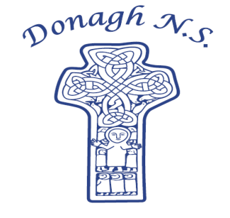 Donagh National School

Carndonagh, Co. Donegal, F93 CX21

Tel: 074 93 74556

Email [office@donaghns.ie](mailto:office@donaghns.ie)

**Dates for your Diary – September & October**

**Mondays:** Pupils from 2nd-6th class will take part in tin whistle & traditional Irish music lessons with Múinteoir Róisín. €2 per pupil, per week.

**Tuesdays:** All pupils will take part in a drama workshop with Emma Porter of Vivid Performances.

**Wednesdays:** Co-operative games with John Gibbons for all pupils.

**Friday, 5th September:** Postal Bible School Prizegivingat 1.00p.m.

**Thursday, 11th September:** School photographs – Please ensure children wear full uniform. Younger/older siblings can attend-just inform the office.

**Wednesday, 24th September:** 2nd - 6th class pupils will attend the Donegal Schools’ Service in Ramelton Presbyterian Church. €5 per pupil towards the cost of transport. Please bring a packed lunch.

**Friday, 24th October:** Hallowe’en Dress up day – see note below.

**Monday, 27th October –** Hallowe’en Holidays –

**Friday, 31st October:**  School reopens Monday, 3th November.

**Hallowe’en Dress up**

As Friday 24th October is the last day before mid-term break, children may wear a simple costume to school. Dressing up is entirely optional. Please may we emphasise that costumes are kept simple and appropriate.e.g. no clowns/very frightening costumes.

**Monies**

***ALL*** money sent to school with children must be in a **sealed envelope** with the **child’s name** clearly stated on the envelope. This avoids confusion for us all.