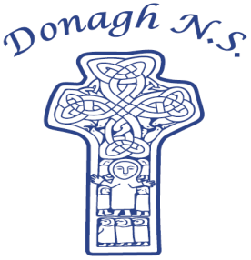
Donagh National School
Carndonagh, Co. Donegal, F93 CX21
Tel: 074 93 74556
Email office@donaghns.ie

Dates for your Diary – November & December

Mondays: Pupils from 2nd-6th class will take part in tin whistle & traditional Irish music lessons with Múinteoir Róisín. €2 per pupil, per week.

Tuesdays: All pupils will take part in a dance & drama workshop with Emma Porter of Vivid Performances.

Wednesdays: Co-operative games with John Gibbons for all pupils.

Tuesday, 11th November: School will close at 12.30p.m. for pupils. Buses will operate for collection time. Please ensure prompt collection of travelling by car.
Parent-Teacher Meetings.
Wednesday, 12th November: 1st-6th class will visit the Millennium Forum, The Derry Walls, The Guildhall and the Void Gallery.
Assembly led by Claire from C.E.F.
Thursday, 13th November: World Kindness Day.
Wednesday, 26th November: Battle of the Books Quiz.
Tuesday, 2nd December: Senior pupils will take part in the Sportshall Athletics Programme in Carndonagh GAA.
Wednesday, 3rd December: Assembly led by Claire from C.E.F.
Monday, 8th December: Trip to the pantomime in The Millennium Forum – Beauty & the Beast.
Friday, 12th December: School Christmas Service in the Hillhead Presbyterian Church at 1p.m. Everyone welcome.

P.T.O.

Monday, 15th December: Christmas Jumper Day in aid of Crumlin Hospital. Please wear your Christmas jumper/t-shirt and bring a small donation.
Thursday, 18th December: Exchange of Secret Santa gifts.
Friday, 19th December: Half day school closure for Christmas Holidays at 12p.m. – School reopens Monday, 5th January 2026.

Secret Santa
The children will exchange their Secret Santa gifts on Thursday, 18th December. We request that all Secret Santa gifts are in school by Friday, 12th December. Class teachers will arrange Secret Santa details with their pupils over the coming week. Gifts should not cost any more than €7.

Reverse Advent Calendar
During the month of December the school will participate in a Reverse Advent Calendar. Each family will be asked to bring in an item of non-perishable food on their day which we will donate to the St.Vincent de Paul. Class teachers will let families know when it is their turn to donate.

