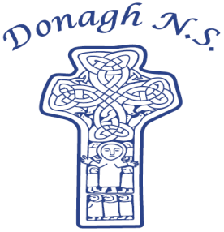
Donagh National School
Carndonagh, Co. Donegal, F93 CX21
Tel: 074 93 74556
Email office@donaghns.ie

Dates for your Diary – April, May & June

Mondays: Pupils from 2nd-6th class will take part in tin whistle & traditional Irish music lessons with Múinteoir Róisín. €2 per pupil, per week.
Pupils from 2nd -6th class will take part in a Fab Lab workshop with Spraoi & Spórt for 5 weeks. Over the 5 weeks the pupils will work on a project based on the Donagh Cross using stop-motion animation, green screens and iPads. Pupils to meet at Spraoi & Sport at 9.10a.m. Those travelling on school buses will be dropped there also.
Tuesday: Senior pupils will take part in Modern Foreign Languages lessons with Mark Spencer in April.
Wednesday: All pupils will take part in a Jujitsu workshop with Danny Hegarty.
Friday: 1st – 6th class pupils will attend swimming lessons in Templemore Sports Complex from April 17th, for a period of 6 weeks.
Hurling skills and co-operative games with Cathal Doherty for all pupils.

Wednesday 22nd April: Assembly led by Claire from C.E.F.
Thursday, 30th April: School closure – New Primary Curriculum Framework Training.

Monday, 4^{h} May: School closed for Bank holiday.
Wednesday, 5th May: Assembly led by Claire from C.E.F.
Monday, 18th May: All pupils will take part in a Biodiversity workshop with Aengus Kennedy.
Wednesday, 27th May: Assembly led by Claire from C.E.F.

P.T.O.

Friday, 29th May: 6th class pupils will take part in a Wood turning workshop with Johnny Shiels.
Monday, 1st June: School closed for Bank holiday.
Wednesday, 10th June: Provisional date for Sports Day with Glentogher N.S.
Venue: Donagh N.S.
Wednesday, 17th June: School Tour to The Ulster American Folk Park for all pupils.
Friday, 19th June: End of Year Service and Celebration at 10.00a.m. in the school. Everyone welcome.

